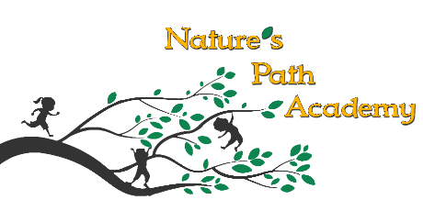

2020-2021 School Year Calendar

September 8th First Day of School
November 3rd Staff Day School Closed
November 6th Developmental Checklists sent home
November 26th & 27th Thanksgiving School Closed
Dec. 24th-Jan 4th Christmas Break School Closed
February 15th Staff Day School Closed
April 1st Easter Egg Hunt 10 am
May 7th Developmental Checklists go home
May 31st Memorial Day School Closed
June 21st Summer Camp Begins

